Supreme Court Cases
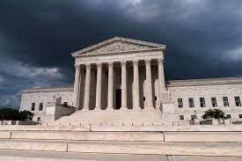
Now that we have a little experience with being trial lawyers, we are ready to argue before the Supreme Court. Our class will have 2 cases—1 involving abortion rights, one involving gun rights. Both are cases that the Supreme Court will be hearing in December (they will not announce decisions until next year).
Roles for the trials
If 5 People:
- Opening Statement
- Witness (should be a real person with knowledge of the case)
- 2nd witness (should be a real person with knowledge of the case)
- Cross-examiner for 1st and 2nd witness
- Closing statement

If 4 people:
- Opening statement
- Witness (should be a real person with knowledge of the case)
- Cross-examiner (may be for one or 2 witnesses)
- Closing statement

If 3 people
- Opening and closing statement
- Witness (should be a real person with knowledge of the case)
- Cross examiner

All roles will get four grades for these trial
- Written preparation (written out speech or bullet points for opening and closing statements, minimum 7 questions with answers for witnesses and cross examiners—expected answers written out)
  - Bibliography
- Presentation performance
- Jury reflection—Explaining your constitutional position
  - Note—When on the jury, you should be deciding based not on your personal beliefs, but on WHAT YOU THINK THE CONSTITUTION MOST ACCURATELY ENDORSES
  - 2nd note—The majority of the time (but not always), the Supreme Court values precedent (what has been decided in past cases). They use precedent to try to stay consistent with what the Court has decided in the past to maintain legal stability.
- Major grade for overall work

